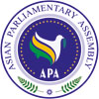

**Final Report of the**

**Standing Committee on Political Affairs**

25-28 June 2019

**Isfahan, Islamic Republic of Iran**

**SC- Political Affairs /Rep/2019/03**

**26 June 2019**

The Standing Committee on Political Affairs of Asian Parliamentary Assembly was held on 25-28 June 2019 in Isfahan, Islamic Republic of Iran. Parliamentary delegations from following member countries participated in the meeting:

Afghanistan, Cambodia, Cyprus, Indonesia, Iran, Iraq, Jordan, Kazakhstan, Lao PDR, Lebanon, Pakistan, Russia, Syria, Turkey and Vietnam. (Attachment I).

Advisory council member of Qatar attended the meeting as observer.

**Inaugural Ceremony:**

The following dignitaries presented their welcome statements and remarks at the opening session:

* H.E. Dr. Abass Rezaei, Governor General of Isfahan.
* H.E. Mrs. Seyedeh Fatemeh Zolghadr, Head of APA Delegation of Iran (Attachment II).
* H.E. Mrs. Asuman Erdogan, Representative of APA President from Turkey (Attachment III).
* H.E. Dr. Mohammad Reza Majidi, APA Secretary General (Attachment IV).
* H.E. Dr. M. Pezeshkian, first vice Speaker of the Islamic Parliament of Iran (Attachment V).

**1. Adoption of the Agenda:**

The Member Parliaments adopted the Draft Agenda of the Standing Committee on political Affairs unanimously. Agenda and Program of Work are as (Attachments VI).

**2. Election of the Bureau:**

The following members of the Bureau were unanimously elected by acclamation:

* Chairperson: H.E. Ms. Chenarani member of the Islamic Parliament of Iran.
* Vice Chairperson: H.E. Senator Syed Shibli faraz Leader of the House / Head of Delegation of Pakistan.
* Rapporteur: H.E. Syamsul Bachri member of the House of Representative of Indonesia.

**3. Opening remarks by Chairperson:**

The chairperson presented her opening remarks.

**4. Report of Secretary-General:**

APA Secretary-General Reported on implementation of the present Draft Resolutions and consideration of proposals to be presented by Member Parliaments. (Attachment VII).

**5. Consideration and discussion on Draft Resolutions:**

At the beginning of the session, Head of the Cyprus delegation informed the meeting that the APA representative of Palestine H.E. Zohair has passed away. He expressed his deep condolences and hailed his active participation in APA meetings and debates while defending the rights of his fellow Palestinians. Other representatives such as Lebanon, Turkey, Syria, Secretary General etc. expressed their sorrow and condolences for his demise.

Delegation of Lebanon proposed to defer consideration of the draft resolution on “Asian Parliaments’ Unwavering Support for The Palestinian people” due to the absence of representative from Palestine. All delegations supported the proposal.

On draft resolution “Towards an Asian Parliament” delegation of Pakistan introduced his amendments and several delegations debated different aspects of Asian Parliament. The chairperson concluded that what emerges from expressed views is that we need AP but there are divergent of views, which need more time to focus on, during future meetings.

Participating Parliamentarians considered and discussed the amendments on draft resolutions: Good Governance, Rule of Law and Judicial Empowerment, Good Parliamentary Practices, Building Prosperity in Asia through Friendship and Cooperation, Asian Parliaments and Governments together for Prosperity in Asia and Harmonious Development through Democracy. The draft resolutions were adopted by consensus.

Iranian delegation introduced a new draft resolution titled: “Enhancing Cooperation among the Members of The Asian Parliamentary Assembly to Protect and Promote Multilateralism”. This resolution was welcomed by all delegations and the chair stated that amendments to this resolution will be considered during next meeting.

6. **Working Group on Asian Parliament:**

H.E. Koohkan, MP from Islamic Parliament of Iran and Chairman of the Working Group on AP (WG-AP) presented his remarks (Attachment VIII). Delegations including Lebanon, Pakistan, Indonesia, Turkey, Jordan, Afghanistan etc. debated on the issue.

Followings are few important views expressed by member participants:

* Creation of AP is a necessity but avoiding any hasty measure in this regard is called for..
* Objectives of AP should be to reach Peace and Social Welfare for Asian People.
* We call on Secretariat to seek expertise views and consult the legal opinion and academia to come up with a roadmap for AP.
* Option of having a Forum in Asia is a must due to economic pressure on all Asian.
* APA should become more visible in the international arena.
* APA can be transformed to AP, only when conflicts among member parliaments are addressed in a committee and dissolved in due time.

**The chairman presented the following concluding remarks:**

* It is important to reach a consensus on the roadmap and move toward AP. In this regard Secretariat should be more active.
* APA should become more visible in international scene.
* Secretariat is to encourage member states, who have not done so, to respond to Questionnaire as soon as possible.
* The Secretariat is to provide a clear procedure on how to solicit the views of Academia, Legal institutions, Governments etc on AP.
* Member Parliaments are requested to provide substantive and complimentary inputs to the issue of AP. The Secretariat will collect the views and call for a WG-AP meeting on the sideline of any Standing Committee meeting provided that sufficient information and proposals are accumulated to generate a genuine debate.
* The WG-AP is under auspicious of Standing Committee on Political Affairs with APA Secretariat functioning as its Secretariat.

7. **Any other matters**:

At the closing session, H.E. Mrs. Seyedeh Fatemeh Zolghadr, Head of APA Delegation of the Islamic Parliament of Iran, expressed her gratitude to all delegations for their active and constructive participation in the debates.

Head of the delegation of Iraq at this meeting, officially invited APA members to attend the meeting of Standing Committee on Budget and Planning due to be held on 3-5 September 2019 in Baghdad.

Several delegations expressed their thanks and appreciation to the Islamic Parliament of Iran for the excellent hospitality and arrangements of the Meeting and to the APA Secretariat as well.

**Attachment I**

**List of Participants**

|  |  |  |
| --- | --- | --- |
|  | Country | Name / Title |
| 1 | Afghanistan | 1- Mr. Mohammad Faisal Samay, Senator /Head of delegation 2- Mr. Wali Shah Naibzada /member of the Upper House 3- Mr. Ashaq Noorani Qarluq /staff of International Relation Department |
| 2 | Cambodia | 1- Mr. KIMYEAT CHHIT, Senator/Vice Chairman of Foreign Affairs committee 2- Mr. CHANTARA NIM /MP, Secretary Foreign Affairs committee 3- Mr. SOCHEAT NGUON /MP, Member of the Commission on Foreign Affairs 4- Mr. BUNLY HOK /Deputy Director of International Relations Department 5- Ms. YUVANNAK LIM /Vice Chief of Multilateral Relations Office 6- Mr. Visothymeak Chea /Officer |
| 3 | Cyprus | 1- Mr. NICOS TORNARITIS /M.P., Head of delegation  2- Mr. CHRISTAKIS TZIOVANIS /M.P., Member of delegation  3- Ms. LOUKIA MOUYI /International Relation Officer, Secretary of delegation |
| 4 | India | 1- Mr. Devesh Uttam /Deputy Chief of Indian Embassy in Tehran |
| 5 | Indonesia | 1- Mr. SYAMSUL BACHRI /Head of Delegation 2- Mr. FATHAN SUBCHI /MP 3- Mr. MOCHAMAD ILYAS /Officer 4- Mr. WIRYAWAN NARENDRO PUTRO /Officer |
| 6 | Iran | 1- Mr. Masoud Pezeshkian /First Deputy of the Parliament 2- Ms. Seyyedeh Fatemeh Zolghadr /Member of the Parliament 3- Ms. Hajar Chenarani /Member of the Parliament 4- Mr. Mohsen Kouhkan Rizi /Member of the Parliament 5- Mr. Jalil Rahimi Jahan Abadi /Member of the Parliament 6- Mr. Ali Kazemi Baba Heidari /Member of the Parliament |
| 7 | Iraq | 1- Ms. Aliah Faliah Owaid / Head of Delegation 2- Mr. Muthana Ameen Anders / MP.  3- Mr. Wisam Mohammed Hussein /Protocol |
| 8 | Jordan | 1- Mr. NAIF AL-HADID / Head of Delegation 2- Mr. MUHANNAD ZRIQAT /Officer |
| 9 | Kazakhstan | 1- Mr. Beibit Mamrayev /MP. Deputy for social and cultural affairs committee 2- Mr. Askhat Orazbay /Ambassador 3- Mr. Gamzat Khairov /Official |
| 10 | Lao PDR | 1- Mr. Viengthavisone Thephachanh /Head of Delegation 2- Mr. Pakaysith Phengkhammy /Officer |
| 11 | Lebanon | 1- HASSAN FADLALLAH /MP. Head of delegation  2- KASSEM HACHEM /MP. Member of the Delegation  3- MOHAMAD FADLALLAH /Adviser |
| 12 | Pakistan | 1- Senator Syed Shibli Faraz- Leader of the House/ Head of delegation  2- Senator Gen (R) Abdul Qayoom  3- Senator Sajjad Hussain Turi  4- Senator Mushahidullah Khan  5- Maj.(R) Syed Hasnain Haider- Additional Secretary/Accompanying Officer 6- Mr. Bilal Bukhari- Assistant Director/Accompanying Officer |
| 13 | Qatar | 1- Mr. Rashid Hamad Al-Meadadi, MP, Shura Council. ( APA Observer state) 2- Mr. Ahmed Mohammed Al-Emadi, Legal Researcher (Secretariat) |
| 14 | Russian Federation | 1- Mr. MIKHAIL EMELIANOV /MP, Head of delegation 2- Ms. YULIA GUSKOVA /SECRETARY 3- Ms. NINA ZENINA /INTERPRETEUR 4- Ms. MARIA BYCHKOVA /INTERPRETEUR |
| 15 | Syria | 1- Mr. NIZAR SKEF /MP,Head of Delegation 2- Mr. FAWAZ ALSHARAA /Member of Parliament  3- Mr. MHD. YAHIA SHAIKHO /Officer |
| 16 | Thailand | 1- Mr. Kallayana /Ambassador of Thailand in Iran 2- Mr. Wanarat /Staff |
| 17 | Turkey | 1- Ms. ASUMAN ERDOĞAN /MP, Head of delegation 2- Ms. MÜŞERREF PERVİN TUBA DURGUT /MP, Member of delegation 3- Mr. VECDİ GÜNDOĞDU /MP, Member of delegation 4- Mr. GÖKMEN TOPLU /Deputy Director, Foreign Relations of GNAT 5- Mr. MURAT HASTÜRK /Senior Officer, Foreign Relations of GNAT |
| 18 | Vietnam | 1- Mr. NGUYEN PHUONG TUAN / MP, Head of Delegation 2- Mr. TO VAN TAM / Member of Delegation 3- Mr. BA DINH TRUC / Official |
| 19 | APA Secretariat | 1- Dr. Mohammad Reza Majidi /Secretary General 2- Amb. Kia Tabatabaee / Deputy Secretary General 3- Mr. Mehdi Mollahosseini / Assistant Secretary General 4- Mr. Mehdi Ghashghavi /Executive Deputy of Secretariat  5- Mr. Seyed Javad Hashemi /Director, International Affairs 6- Mr. Saeed Sohrabinia /Director of Information Technology 7- Mr. Mohammad Abolhasani /Staff 8- Mr. Milad Farahani /Staff |

A**ttachment II**

**Opening remarks by H.E. Seyedeh Fatemeh Zolghadr**

**Head of APA Delegation of the Islamic Parliament of Iran**

**Honorable First Deputy Speaker of Iran’s Islamic Parliament;**

**Honorable MPs of Iran’s Islamic Parliament;**

**Honorable MPs and APA Parliamentary Delegations;**

**Honorable Governor-General of Isfahan;**

**Esteemed APA Secretary General;**

**Distinguished Guests and Participants;**

**Ladies and Gentlemen;**

**As-salamu alaykum and good morning to you all!**

On behalf of Iran’s Islamic Parliament and myself, I welcome all dear guests and distinguished friends from APA member states and I appreciate your participation in the Standing Committee meeting on Political Affairs, here in historical and magnificent city of Isfahan. We value your presence.

Also, I am sincerely grateful to H.E. Speaker Larijani for hosting the meeting of this Committee and H.E. Deputy Speaker Pezeshkian for taking part in the inaugural ceremony and the entire staff of the Iran’s Parliament for organizing and convening this meeting.

My special thanks also go to Governor-General Rezaei and his team in the Isfahan Provincial Government for hosting and excellent hospitality and also my colleagues in the Secretariat for their efforts in convening the meeting.

**Dear colleagues;**

This meeting provides us another opportunity to dedicate our collective ideas and energy to materialize parliaments’ roles and participation in facilitating political affairs in Asia.

You are well aware that recently considerable shifts and developments have been taken place in different parts of Asia. Obviously, it requires supportive policy making and law making aimed at proactively and purposefully involving governments in the settlement of challenges as well as taking vital role in establishing peace, security and development in Asia under constructive engagement. This is indeed the core objective of the Asian Parliamentary Assembly (APA).

In this regard, I am quite confident your precious participation, endorsement and guidance in this meeting will contribute to the reinforcement of dialogue, comprehension of best practices and experiences and fulfillment of related objectives in political affairs for the sake of integrating common values and pursuing joint objectives in Asia. From this parliamentary meeting, expectation for fruitful and practical discussions is high.

**Esteemed colleagues,**

**Ladies and Gentlemen,**

I would like to – once more – extend my sincere welcome to you and I wish you a pleasant time and congenial experience during your stay in the beautiful city of Isfahan.

**Attachment III**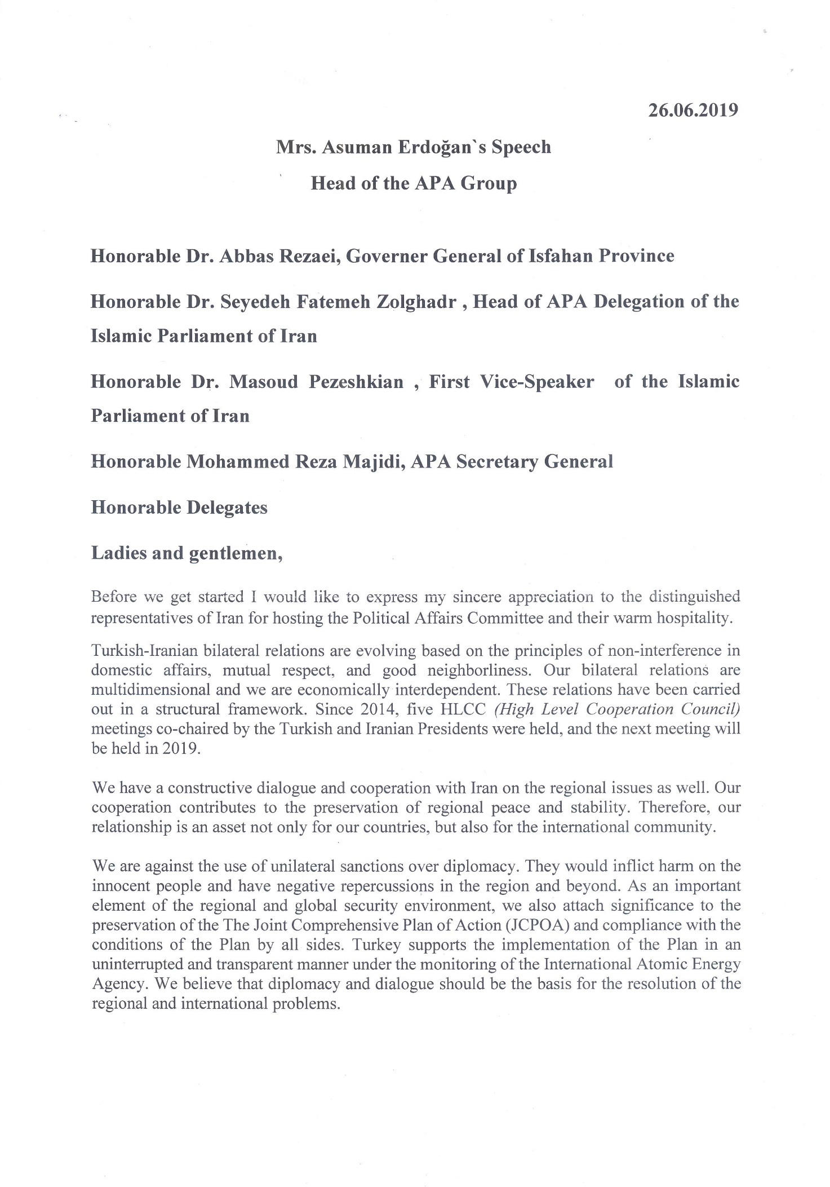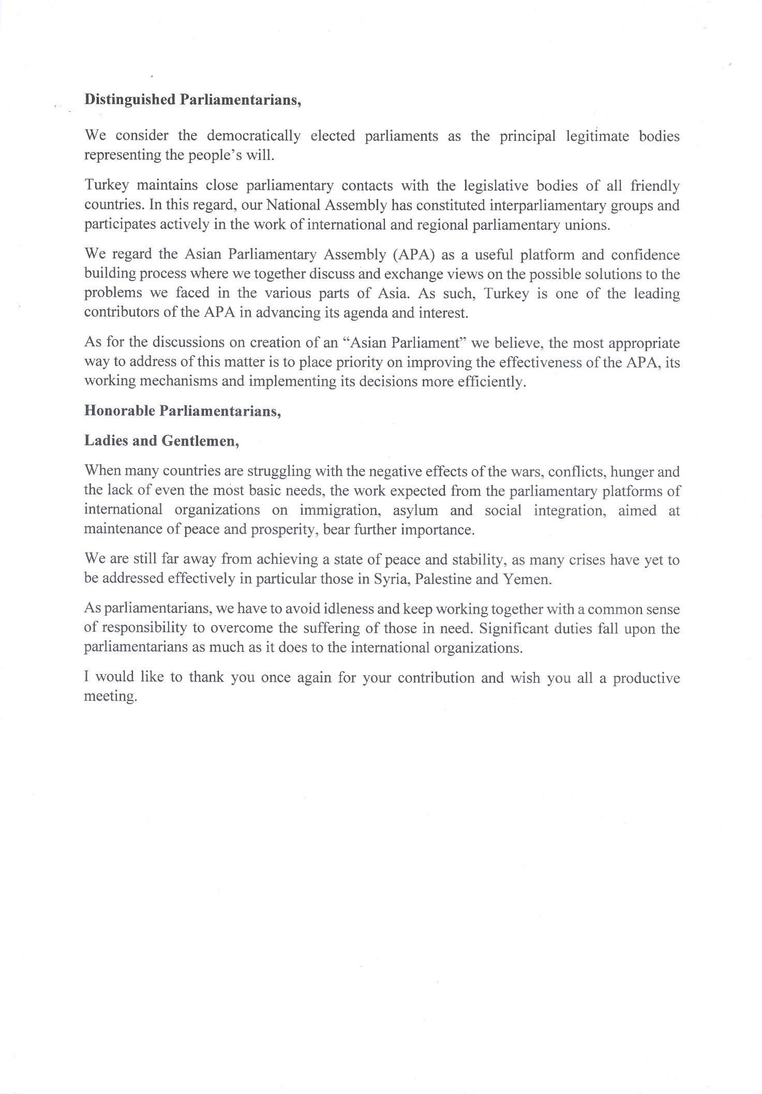

**Attachment IV**



**Opening Remarks**

**by His Excellency Dr. Mohammad Reza Majidi**

**Secretary General of the Asian Parliamentary Assembly**

**June 25-28, 2019**

**Isfahan –Islamic Republic of Iran**

**In the Name of God**

**Madame Chair**

**Distinguished Delegates, Ladies and Gentlemen**

It is a great pleasure for me to have the privileges of addressing the august Meeting of APA Standing Committee on Political Affairs. I also would like to take this great opportunity in my capacity as the APA Secretary General to sincerely welcome you, the honorable guests of the Islamic Parliament of Iran for your presence here in the fascinating historical city of Isfahan;  the capital of art and culture in the Islamic Republic of Iran.

 On behalf of all the participating delegations and myself, I have the honor to express my heartfelt gratitude to Her Excellency Mrs. *Seyedeh Fatemeh Zolghadr,* Head of the APA delegation of the Islamic Parliament of Iran for her kind invitation of the APA Member Parliaments and other high ranking officials of the Government and the Parliament of Iran. My sincere thanks also goes to His Excellency, Dr. Abbas Rezaei, Governor General of Isfahan Province for his generous hospitality and excellent organization of our Meeting here at Kosar Hotel of Isfahan.

 It is also an honor and privilege for the Asian Parliamentary Assembly to have the Islamic Republic of Iran as one of the most dedicated and active members of its community and its permanent host of the APA General Secretariat in Tehran to once again chair the Standing Committee on Political Affairs.

**Madame Chair**

We all share the same opinion that the APA Standing Committee on Political Affairs since convening of the first Political Session in Tehran (Nov. 2006), has made unreserved efforts to raise the most challenging political issues of common concern to all the APA member parliaments.

 At that meeting, the participants expressed their concern over the growing resort to unilateralism and unilaterally imposed measures in international relations as a cause of undermining the UN Charter and international Law.

 The participants firmly rejected any coercive economic measures and unilateral sanctions. The imposition of such measures under whatever pretexts which adversely affect the well-being and daily lives of ordinary people, were also rejected as measures in contradiction of the principles of multilateral free trade system rules was also rejected

During all these years, we have been able to bring up the most crucial issues as such under the auspices of the chair of the committee from different parliaments who wholeheartedly tried to tackle the issues under deliberation. However, much remains to be done in the years ahead.

 I am confident that under your able stewardship and sagacity as well as the leadership of the Islamic Parliament of Iran, APA will spare no efforts to take greater paces to achieve the objectives envisaged in its Charter.

 Madame Chair,

I would like to conclude by wishing you all fruitful and constructive deliberations during the morning session of the Standing Committee Meeting and the meeting of the Working Group on AP in the afternoon session.

Thank you for your attention

**Attachment V**

**Speech delivered by**

**H.E. Dr. Pezeshkian**

**First Deputy Speaker of Iran’s Islamic Parliament**

**at the Inaugural Ceremony of APA’s Political Committee**

**بسم الله الرحمن الرحیم**

**Distinguished guests,**

**Honorable parliamentary delegates,**

**Esteemed participants,**

I would like to extend my gratitude to the parliamentary delegations participating in the APA’s Political Committee. A warm welcome to distinguished guests and I am so pleased to take part in this meeting.

Also, I appreciate all efforts of Isfahan Provincial Government, Iran’s Islamic Parliament and the APA secretariat for organizing and convening the meeting. I hope this meeting would be a successful step in strengthening cooperation and integrity on political affairs among APA’s member parliaments and laying a purposeful ground for establishing and reinforcing cooperation in vast and progressive Asia Continent with the purpose of confronting challenges and reaching sustainable and inclusive peace and security.

**Distinguished colleagues,**

You are well aware that despite existing challenges, the Asian Continent has triggered its growing development and dignified revival of its determining role in the international system. As enjoying major elements of power for further influence and role playing in global community, Asia requires taking preliminary steps and establishing infrastructures to meet collective objectives of the Asian countries. Polylateral coalitions and regional institutions and their reinforcement within multilateralism discourse – which is under severe threats by some countries – raise proper framework and environment for further role-playing in various domains. One of its salient manifestations is the foundation of parliamentary assemblies such as APA.

Despite some constraints for parliaments and parliamentary forums due to their specific situations and features, role of parliaments and accordingly parliamentary diplomacy in different international issues will constantly be increased and the complexity and interconnectedness of domestic affairs with foreign and international issues as well as shifts and developments in the international relations augment the significance of parliaments in global affairs and their role in decision-making and decision-taking in political fields. Therefore, we are currently witnessing a growing trend and development in parliamentary diplomacy and its influential role in various issues and political affairs in particular.

In that context and given these shifts and developments, role playing of Asian parliaments – as an embodiment of the voices of the Asians – is vehemently pursuing through reinforcement of inter-parliamentary engagement of member parliaments within the APA in order to take further, better and bigger steps, review issues in depth and create proper conditions for governments with the purpose of inter-cooperation.

**Distinguished colleagues,**

**Ladies and Gentlemen,**

Among major barriers and struggles in developing and improving international cooperation are unilateralism and coercive measures of some specific governments, cruel sanctions policy, either clandestine or visible nurturing and support and exploitation of terrorism by some powers and attempts to destabilize vital countries and regions. The last instance of this behavior is the intrusion of US spy drone to Iran’s airspace which of course faced with proportionate response of the Islamic Republic of Iran.

To our belief, such struggles are able to be settled via joint efforts and adherence to multilateralism; thus this approach needs to be put in the agenda of the APA’s member parliaments and the political actions of the Asian governments to be directed in the path of reinforcing political, social and economic cooperation as well as creating required capacities for the embeddedness of the rule of law and confrontation of unilateral and coercive measures and inhumane policies which place the life and development of the Asian nations in peril.

Besides to this measure, in order that the APA to play a proactive role in creating national parliaments’ capacity, it is of utmost importance to steer cooperation more purposefully and some progress in a number of issues need to be done. I think after more than one decade of APA existence, it is high time to ask the honorable Secretary General to identify practical issues from resolutions of different committees and urge member parliaments to submit an implementation report to the next meeting of each committee. This forward and progressive step opens space for collective decision making on joint legislation. Commencing joint law making even around issues requiring further cooperation and coordination could be a proper starting point in reinforcing inter-parliamentary cooperation.

I believe this measure creates an appropriate path for the foundation of the Asian Parliament which is an idealistic goal and is in the agenda of this meeting. As you might know, given the specific situation of the Asian Continent, conceptualizing and institutionalizing Asian Parliament as the most extensive regional parliaments in the world is a long-term and complex process and numerous struggles in between need to be resolved.

The most logical and the fastest ways for attaining the declared goals are:

1) to strengthen APA and move forward the process for foundation of the Asian Parliament;

2) to value efforts and supports of the member parliaments as well as the constant attempts of the Secretariat and its experience during the existence of the APA; and

3) to outline a specific but realistic roadmap in a more careful, methodical and principled move which paves the way for the establishment of the Asian Parliament.

Meticulous review as well as constructive cooperation and interaction among APA members are keys to settle challenges and meet the expectations in the APA.

Iran’s Islamic Parliament has enjoyed deep and enduring link and cooperation with the APA and has not spared any efforts for APA exaltation and will dedicate its backing to this Assembly due to optimism to the future of the APA and I recommend to move forward the APA with the thoughts, resolve and determination of ourselves and our governments in a way that our nations and the vast and key Asian Continent deserve.

To conclude, the Government and Parliament of the Islamic Republic of Iran believe in and are committed to common and long-term interests in cooperation with other countries in various domains and they are ready and capable to achieve security and just and peace in Asia.

I hope today’s contribution and discussions would be effective in identifying common approaches and advancing declared goals for Asia.

I – once more – treasure your participation in the meeting of the APA’s political Committee in Isfahan.

I thank you!

**Attachments VI**

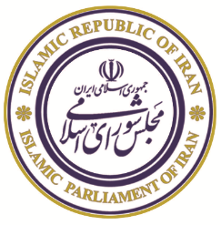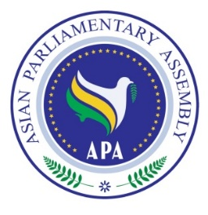

**The Meeting of APA Standing Committee**

**on Political Affairs**

25-28 June 2019

Isfahan, Islamic Republic of Iran

**Agenda**

1- Adoption of the Agenda

2- Election of the Bureau

3- Opening Remarks by Chairperson

4- Report of APASecretary General

5- Consideration of:

* Draft Resolution on Towards an Asian Parliament.
* Draft Resolution on Good Governance.
* Draft Resolution on Rule of Law and Judicial Empowerment.
* Draft Resolution on Good Parliamentary Practices.
* Draft Resolution on Building Prosperity in Asia through Friendship and Cooperation.
* Draft Resolution on Asian Parliaments and Governments Together for Prosperity in Asia.
* Draft Resolution on Asian Parliaments’ Unwavering Support for the Palestinian People.
* Draft Resolution on Harmonious Development through Democracy
* New Draft Resolution on Enhancing Cooperation among the Members of the Asian Parliamentary Assembly to Protect and Promote Multilateralism

6- Working Group on Asian Parliament

7- Any other matters

8- Closing Session

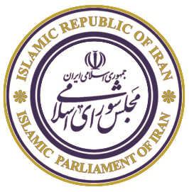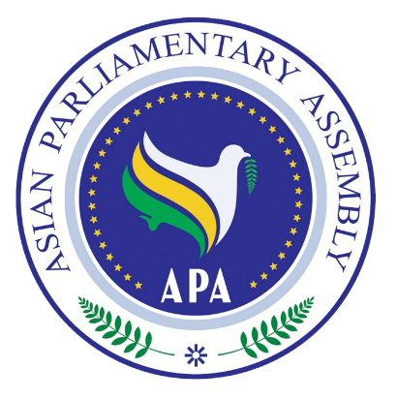

|  |  |  |
| --- | --- | --- |
|  | **ASIAN PARLIAMENTARY ASSEMBLY (APA)**  **The Meeting of APA Standing Committee on Political Affairs**  **Kosar Hotel, Isfahan, Iran**  **25 - 28 June 2019**  **Working Program** |  |

|  |  |
| --- | --- |
| **Tuesday, 25 June 2019** |  |
| All Day | Arrival of Delegations (Proceed to Kosar Hotel)  Accommodation & Registration |
| 16:30 – 20: 30 | City sightseeing and shopping |
| 21:00 | Dinner buffet by the Host Parliament  *Venue:* Zarrin Hall , Kosar Hotel |
| **Wednesday, 26 June 2019** |  |
| 07:00 – 08:30 | Breakfast |
| 08:30- 08: 45 | Arrival of delegations to the Meeting Hall  *Venue:* Cheshmandaz Neging Hall, Kosar Hotel |
| 09:00 – 10:00 | **Opening Ceremony**   * National Anthem  * Recitation from Holy Quran * Remarks by H.E. Dr. Abbas Rezaei, Governor General of Isfahan Province * Remarks by H.E. Dr. Seyedeh Fatemeh Zolghadr, Head of APA delegation of Islamic Parliament of Iran * Remarks by H.E. Ms. Asuman Erdoğan, Rep. of APA President * Remarks by H.E. Dr. Mohammad Reza Majidi, APA Secretary General * Remarks by H.E. Dr. Masoud Pezeshkian First Vice-Speaker of the Islamic Parliament of Iran   *Venue:* Cheshmandaz Neging Hall, , Kosar Hotel |
| 10:00 – 10:30 | Photo Session & Tea/Coffee Break |
| 10:30 – 13: 00 | **Meeting of the Standing Committee on Political Affairs**  - Adoption of the Agenda  - Election of Bureau (Vice-Chair, Rapporteur)  - Opening remarks by the Chairman  - Report by the APA Secretary General  - Consideration of draft resolutions:   * Draft Resolution on Towards an Asian Parliament. * Draft Resolution on Good Governance. * Draft Resolution on Rule of Law and Judicial Empowerment. * Draft Resolution on Good Parliamentary Practices. * Draft Resolution on Building Prosperity in Asia through Friendship and Cooperation. * Draft Resolution on Asian Parliaments and Governments Together for Prosperity in Asia. * Draft Resolution on Asian Parliaments’ Unwavering Support for the Palestinian People. * Draft Resolution on Harmonious Development through Democracy * New Draft Resolution on Enhancing Cooperation among the Members of the Asian Parliamentary Assembly to Protect and Promote Multilateralism   *Venue:* Cheshmandaz Neging Hall, , Kosar Hotel |
| 13:00 – 14:30 | Lunch  *Venue:* Zarrin Hall ,Kosar Hotel |
| 14:30 – 16:00 | **Working Group meeting on Asian Parliament**  *Venue:* Cheshmandaz Neging Hall, , Kosar Hotel |
| 16:00 – 17:00 | Tea/Coffee Break |
| 17:00 – 18:00 | Closing Session (Adoption of Final Report) |
| 20:00 | Dinner hosted by H.E Dr. Abbas Rezaei, Governor General of Isfahan Province  *Venue:*Zarrin Hall ,Kosar Hotel |
|  |  |
| **Thursday, 27 June 2019** |  |
| 08:30 – 18:00 | **Cultural Program:** |
| 13:00 | Launch Reception by the Isfahan Mayor  *Venue: Abbassi Hotel* |
| 19:00 | * Meeting with Economic Entrepreneurs * Dinner hosted by Isfahan Chamber of Commerce, Industry, Mines and Agriculture   *Venue: Chamber of Commerce* |
|  |  |
| **Friday, 28 June 2019** |  |
| All Day | Departure of Delegations |

**Attachment VII**



**ASIAN PARLIAMENTARY ASSEMBLY**

**The Meeting of APA Standing Committee on Political Affairs**

**25-28 June 2019**

**(Isfahan, Iran)**

**Report of the APA Secretary General**

Mr. Chairman,

Distinguished Delegate,

Dear Colleagues,

I have the distinct pleasure to address, once again, this important meeting as Secretary General of the APA, presenting a brief report on the activities of our Standing Committee on Political Affairs.

Before I begin with presentation of my report, allow me to take this opportunity to express, on behalf of myself and my colleagues in the APA General Secretariat, my deepest appreciation to the Islamic Parliament of Iran and the state officials, most particularly the distinguished Governor General of Isfahan Province, who took the burden of holding our meeting through excellent organization and unique hospitality at the capital of Persian-Islamic architecture, the city of Isfahan.

**Excellencies,**

According to the outcome documents of our last Standing Committee meeting in Gwadar of Pakistan, 30 October 2018 and endorsement of the eleventh Plenary in Istanbul, there are eight draft resolutions before you for consideration. These draft documents are to be hammered out here and proposed for further approval of the Executive Council meeting due in September 2019. In addition, we have one new draft resolution for consideration by the Committee. This new draft, which has been tabled by the Host Parliament, entitles:

“*Enhancing Cooperation among the Members of the Asian Parliamentary Assembly to protect and Promote Multilateralism*” for consideration of the Committee.

The scope of draft resolutions covers the following areas:

1. Towards an Asian Parliament;

2. Good Governance;

3. Rule of Law and Judicial Empowerment;

4. Good Parliamentary Practices;

5. Building Prosperity in Asia;

6. Asian Parliaments and Governments Together for Prosperity in Asia;

7. Asian Parliaments’ Unwavering Support for the Palestinian People;

8. Harmonious Development through Democracy;

On Asian Parliament, as I reported to the meeting of 29 October 2018, in Gwadar of Pakistan, Asian Parliament is the ultimate goal of Asian Parliamentary Assembly and we are thankful to the Senate of Pakistan for its continued efforts to promote this idea. However, as all APA members emphasize it, we are in the beginning of a long way and converting APA to Asian Parliament is a long-term project and needs a lot of understanding and coordination among Asian countries. Therefore, based on the consensus emerging from the interventions of the Member Parliaments in the Political Standing Committee and the draft resolution, proposed by the distinguished delegation of Pakistan, there was a request to form an open-ended working group to follow up and develop the idea of Asian Parliament. To this end, APA Secretariat prepared a Questioner together with a comprehensive research under the title of *“The Foundations of Asian Parliament*” and sent it to all APA members in November 2018. As a result, the first WG-AP was held on 14 Feb. 2019 with participation of interested APA members on the sideline of the SC on Social and Cultural Affairs in Bangkok, Thailand. The meeting was chaired by Iran as the Chairman of Political Standing Committee. Following an extensive debate, it was agreed that the next meeting of Working Group to be held in Kuwait within 15 days and at the same time members were urged to respond to the distributed Questionnaire. To date, we have received 15 responses and we intend to discuss the issue today afternoon within the framework of the Working Group on AP.

On good governance, we reiterate that it is a key to achieving inclusive economic, social and institutional development and suggeststhat member parliaments may provide indicators for good governance. Under this draft, we alsocall uponthe Members to ensure participation of women, youth and minorities in the national political process.

On the rule of law, we stressthe importance of civilian capacity development through rule of law and urgemembers to ensure compliance with international humanitarian laws. We alsoreiterateour strong and unequivocal condemnation of terrorism and extremism in all its forms and manifestations, committed by whomever, wherever and for whatever purposes, as it constitutes one of the most serious threats to the rule of law.

On good parliamentary practices, we urgeAPA Members to adopt transparent modes of public communications and urge them to devise effective outreach mechanisms for engagement with public for ensuring public confidence. Member Parliaments also encouraged streamlining of their legislative process. The task of oversight of the executive, particularly, in the formulation of international policy, and making recommendations to their respective governments was also emphasized.

On building prosperity in Asia, we urge collective efforts by all Asian to provide humanitarian assistance of all kind to vulnerable people in war- torn countries and call upon themto direct their diplomatic efforts at reducing political tensions in Asia. We also encourage Asian academic institutions, think tanks and research centers, universities and educational institutions to take part in promoting the tenets and guidelines enshrined in the APA Declaration on the Principles of Friendship and Cooperation in Asia.

The Standing Committee draft resolutions addresses central issues, challenges and concerns of our Asian societies and thus are considered of utmost importance to each and all of us. Therefore, I would like to recommend you to tale due note of the contents and the ideas brought up under theses resolutions and do your best to enrich them substantially.

Thank you very much

**Attachment VIII**

**Statement by H.E. Mr. Mohsen Kouhkan Rizi**

**Member of the Parliament and head of the delegation of the Islamic Consultative Assembly of Iran to the APA Working Group on the Asian Parliament**

**Isfahan, Iran, 26 June 2019**

In the Name of God, the Compassionate, the Merciful

**Mr. Chairman,**

The Islamic consultative assembly of Iran has been one of the chief proponents of the establishment of an Asian parliament by emphasizing prior experience in parliamentary convergence in the ancient continent of Asia, particularly by promoting the current status of the Asian parliamentary assembly (APA) and gradually developing it into an inclusive regional parliamentary institution, and for years it has invested considerable human and financial resources to materialize this significant goal. It goes without saying that this goal may not be achieved without paying sufficient attention to political, economic, ethnic, religious, cultural, and social areas in Asia and studying the lessons taken from other regions.

Iran believes that the idea of establishment of an Asian parliament belongs to all Asian nations and all member parliaments, and hence the opinions and considerations of all of them in this regard must be taken into account. Moreover, the establishment of the Asian parliament is a subset of the grand goal of creating Asian convergence which falls within the mandate of the governments and hence its pursuit must be a function of general agreements among Asian governments on regional convergence whose realization has so far been deeply challenged by various differences and conflicts among Asian nations. Therefore, discussing the establishment of an inclusive Asian parliament without considering the theoretical, political, economic, and security grounds as well as functional and operational requirements including internal laws and national ratification procedures is speaking in a vacuum and therefore does not stand much chance for success.

**Mr. Chairman,**

We believe that consultation and sharing opinions on the establishment of an Asian parliament must initially take place at national and sub-regional levels and afterwards the feedback should be submitted appropriately to the APA secretariat to undergo detailed investigation within the APA framework. After investigating the national views, the member parliaments of the APA may come to a clear conclusion on the possibility of pursuing such an establishment in the current conditions of Asia. Since it will be impossible to launch such a grand project without basing it upon the support of an active regional parliamentary institution, the secretariat will confer with scientific and academic communities inside and outside the region as well as other regional parliamentary organizations outside Asia such as the European parliament, studies the pathology of such an important matter and identifies the impediments and challenges as well as opportunities and possibilities, and proposes an appropriate theoretical-operational structure through a clear strategy focused upon the goal of "developing the current structure of the APA into an Asian parliament."

In the regard, we emphasize that any intended activity towards the establishment of an Asian parliament, due to its nature, must be directly managed and monitored by the Standing Committee on Political Affairs of the APA, and the committee and working groups to be established must report on its activities as a subsidiary institution of the APA to the standing committee on political affairs for investigation and ratification. As emphasized by the documents adopted by the previous APA meetings, the establishment of a working group for addressing the establishment of an Asian parliament has been carried out by the Standing Committee on the Political Affairs of the APA and hence all its activities must be monitored by the Standing Committee on the Political Affairs as its co-founder and in full coordination with the APA secretariat and there is no need for establishing a separate or independent mechanism in this regard. According to the previous agreements of the APA members, the aforesaid committee will be established as a subsidiary institution of the APA and must act within the APA framework and in full coordination with other organs particularly the secretariat.

**Mr. Chairman,**

The Islamic consultative assembly of Iran believes that the APA has a significant responsibility to promote and contribute to the realization of the idea of establishment of an Asian parliament. We hope by providing the opportunity for consultation and exchange of opinion among the participants this meeting can lay the foundation for a serious discussion on the establishment of a logical study and negotiation procedure to investigate the possibility of achieving more realistic solutions for creating convergence among the parliaments of Asian countries, such that the primary interests of countries do not fall victim to unreasonable political haste and that such an issue be addressed on a logical basis ensuring the collective interests of Asian nations and governments.

While supporting the actions and efforts taken through the "working group for the establishment of an Asian parliament," the Islamic consultative assembly of Iran believes that the future activities of the committee must take account of the aforementioned conditions and considerations. While re-expressing our gratitude for the actions and efforts carious out to advance the initiative of establishing an Asian parliament, we belief that due to considerable political sensitivities and numerous and diverse political, economic, security, cultural, ethnic, and religious components in the Asia, the realization of such a plan requires designing a complicated, exhaustive, foresightful, and realistic study as well as a negotiation procedure within the framework of the APA in order to identify the significant challenges and impediments to the materialization of this idea and provide logical responses to the numerous questions and concerns in this regard.

In this regard, we wish to reiterate that there are various forms of consultative parliaments and councils in the Asian continent as there are different cultural, political and religious backgrounds. A significant number of the countries in this continent have advisory bodies assisting the leaders. The members of such bodies are appointed by political leaders without direct popular elections and serve advisory purposes. Hence, considering this objective reality, the first primary precondition for the realization of the idea of establishment of an Asian parliament is establishing independent, inclusive parliaments all members of which are elected by direct popular vote and find their way to the legislative assemblies through ballot boxes as symbols of modern democracy. Only then will we be able to speak of the establishment of an inclusive continental parliament, because not only is the presence of councils appointed by the executive powers among genuine and democratic parliaments completely at variance with the progressive goal of establishment of a regional parliament, but it also creates a perilous situation where the executive powers can directly exert their influence on decision-making and free collaboration among genuine parliaments. Such a reality makes it difficult to compare an Asian parliament with successful experiences such as the European parliament. Furthermore, the formation of an Asian parliament requires planning and implementing exhaustive and intensive training activities on national levels in the Asian continent in order to familiarize the people of different countries with the projected benefits of an Asian parliament for the ancient continent and lay the foundation for the formation of a genuine parliament and the creation of consensus among the governments and peoples of all Asian countries. Obviously, the realization of this goal requires a lengthy and time-consuming process.

Mr. Chairman,

In conclusion, I would like to present a brief summary of the views of the Islamic Parliament of Iran on the manner of addressing the several aspects of an Asian parliament:

1. The historical development of Asia has been one of the main themes of international relations in the post-cold-war era. The end of the cold war opened a new horizon in the history of contemporary Asia and laid the foundation for the gradual return of the ancient continent into the orbit of world economy, politics, and culture. This trend was further expedited and deepened by the beginning of the 21st century. Endowed with significant historical, geopolitical, civilizational, cultural, economic, and social characteristics, Asia has gradually and increasingly turned into one of the hubs of international relations. In this process, Asian convergence including coordination between parliamentary activities at a continental level has gained significance as an effective supplement to intergovernmental activities.
2. An investigation of process of regionalism in Asian regions demonstrates the fact that the Asian identity has not been at the core of the institutionalized cooperation among the Asian countries and hence the continent continues to suffer from a kind of "identity deficit." In other words, although regional convergence, including in parliamentary activities, stems initially from intergovernmental bargaining, its advancement is dependent on defining and developing a clear regional identity that is acceptable to all. Achieving such an identity has been impeded, among other things, by the clear differences among Asian nation-states. Therefore, the establishment of an Asian parliament must be a function of this important principle and be considered as a developmental goal which can be achieved over time.
3. Disintegration and completely discrepant demarcations in terms of ethnicity, race and religion as well as discrepant and often-conflicting definitions of national interests stemming from differences of opinions, views, and, approaches stemming from different ideological and political standpoints in the field of power politics and the existence of serious sensitivities and competitions in social, security and economic fields are some of the current major characteristics of the Asian community. For this reason, due to geographical, historical, political, and cultural contingencies as well as the relations among Asian nations and countries, Asian parliamentary convergence has been beset by a host of challenges and impediments. As a matter of fact, with regard to power, Asia has been at the crossroads of diverse and conflicting political visions, which is why the structures of political cooperation and convergence still appear fragile. The diversity of national and sub-regional institutions and diverse forms of cooperation stemming from different social and religious ideologies as well as the great number of different Asian actors and powers has been one of the main causes of impossibility of political convergence and the consequent non-realization of the idea of an Asian parliament in the medium term on the continent. Furthermore, the type of bonds that some Asian countries share with extra-regional powers is another challenge to convergence in Asia. For this reason, considering their different ideological, cultural, and religious viewpoints, continental and supra-continental powers may adopt different narratives about and approaches to regionalism and parliamentarianism, which, despite some overlaps, seek competition-inducing goals and visions which make it difficult to create a consensus.
4. Given the recency of the debate on the Asian parliament and the very complicated political, security, economic, cultural, religious, and ethnic conditions of Asian countries which have caused them to enjoy different levels of democracy, including the existence of national parliaments, any haste in investigating such an important matter which is a function of the principal goal of convergence among Asian countries can lead to serious deviation in the definition of realistic and practical goals and solutions in this connection.
5. Having been recognized as the leader of the grand movement of Asian countries towards the establishment of an inclusive regional parliamentary institution, the APA can reasonably serve as a medium through which to continue on the path of parliamentary convergence in Asia. Hence, in order to ensure the health and legitimacy of actions, any move or activity towards the establishment of an Asian parliament must be based upon the APA mandate and negotiated and operationalized within the framework of its goals and purposes by its Standing Committee on Political Affairs as a superior and inclusive Asian parliamentary institution.
6. The points on the agenda of the Working Group on the Asian parliament as a subsidiary component of the Standing Committee on the Political Affairs of the APA as well as the initial report of the APA Secretariat on the responses of some APA members to the questions regarding the Asian Parliament demonstrates the existence of discrepant interpretations of a small number of member parliaments which responded to the questions on the existential necessity of the establishment and the manner of pursuit of the Asian parliament. In other words, the reaction of a small number of members exhibits different levels of the sense of need for such an institution based upon the real conditions of each country. Considering the existence of different viewpoints among the members, any practical action with regard to the Asian parliament is contingent upon the final discussion drawn from the responses submitted by all the national parliaments of APA members. It goes without saying that receiving the views of all member parliaments is the principal condition for ensuring organizational democracy. Hence, any planning for practical action in this respect will be inconsistent with democracy and therefore unacceptable prior to receiving all the view.
7. Accordingly, the text of the APA resolution should be drafted and adopted by considering this reality, and no provisions stipulating specific executive and financial commitments for the APA members should be contained in the text prior to receiving the viewpoints of all the member parliaments.